**MODAL ANALYSIS OF A THIN PLATE AND ITS STRUCTURAL MODIFICATION FOR THE APPLICATION IN AEROSPACE SYSTEM**

#### A project report submitted in partial fulfillment of the Requirements for the course of

**MECHANICAL VIBRATION**

## *in*

**M-TECH**

*by*

**Singh Abhishek Ranjan (224103432)**

**Imdad Hussain (224103214)**

**Rohit Ramakant Kadam (224103427)**



**DEPARTMENT OF MECHANICAL ENGINEERING**

**INDIAN INSTITUTE OF TECHNOLOGY**

**GUWAHATI**



**DECLARATION**

We hereby declare that the work report entitled “**Modal analysis of a thin plate and its structural modification for the application in aerospace system**” submitted by us to Indian Institute of Technology, Guwahati in partial fulfilment of the requirements for the course of **Mechanical vibration** is a record of bonafide work carried out by us. We declare that this report represents our concepts written in our own words and where other’s ideas or words have been included, we have adequately cited and referenced the original sources. We further declare that we have adhered to all principles of academic honesty and integrity and have not misrepresented or fabricated or falsified any idea/data/fact/source in our submission. Further we affirm that the contents in this report have not been submitted and will not be submitted either in part or in full for any other course and same is certified.

**ACKNOWLEDGMENT**

## We would like to thank our professor [Santosha K. Dwivedy](https://www.iitg.ac.in/mech/faculty/dwivedy/) and his teaching assistants Patel Bhavik Maheshkumar and Ranit Roy for giving us the opportunity to work on the project and guiding us. It was a great learning experience.

## We would also like to take this opportunity to express gratitude to all the members of the group for individual inputs and cooperation, without which the project would have not been successful.

**TABLE OF CONTENTS**

**CHAPTER NO. TITLE PAGE NO.**

**ABSTRACT** I

**LIST OF TABLES** II

**LIST OF FIGURES** III

**LIST OF SYMBOLS AND ABBREVIATIONS** IV

**1. INTRODUCTION AND LITERATURE REVIEW** 1

**2. METHODOLOGY AND SIMULATION** 5

**3. RESULTS AND DISCUSSION** 18

**4. CONCLUSIONS** 29

**REFERENCES**  30

# ABSTRACT

# Modal analysis is a free vibration analysis used to calculate the modes shape and frequency of a system. It is the first step for any dynamic analysis. In this work modal analysis of thin square plate is carried out with different boundary conditions. This work shows the frequency dependencies on boundary condition, material and dimension of plate. Various graphs of frequency as a function of fixed-fixed boundary condition. Free-free boundary condition is plotted. steel and aluminum are chosen as material for thin plate. After the completion of modal analysis, whether the frequencies are compatible with the aerospace system or not is checked. For this, the desired fundamental frequency must be out of the bandwidth of frequency prescribed by MILSTD 810 H. since we are unable to achieve this, we have tried to modify the design to make suitable for aerospace system. Modification includes addition of stiffener to the plate. Stiffener increase the stiffness of the system and hence increases the frequency. Simply adding stiffener does not make system stiff. We need to see the modes shape of system and accordingly stiffener are added to suppress the corresponding mode and make body stiffer. In this work steps and procedure for experimental modal analysis of thin square plate is also provided. The validation of data is done by FEA using NX NASTRAN. The accuracy of analytical approach using wave equation and fem approach is compared and errors are plotted accordingly. FEA is performed with high precision using very fine mesh size and proper boundary condition. All the respective graph are compared their counterpart graph obtain though analytical approach. MATLAB is used to calculate the mode shape and frequency of thin square plate. A standard sophisticated Graphical User Interface is created to make the calculation easy. The variables being material, boundary conditions, dimensions are properly used in place to calculate the modes and frequency.

In this work we have tried to combine the modal analysis from different literature to the real physical world in a simpler manner. The use of FEA in order to validate the data is one of the ways to bring the theoretical nature of modal analysis into physical world.

# LIST OF TABLES

|  |  |  |
| --- | --- | --- |
| TableNo. | Title | PageNo. |
| Table 2.1 | Shows Properties of specimen plate when different materials are considered. | 07 |
| Table 2.2 | Shows the Analytical values of frequency obtained in MATLAB for fixed-fixed boundary condition | 13 |
| Table 2.3 | Shows frequency at different modes for fixed- fixed boundary condition | 15 |
| Table 2.4 | Shows different mode frequencies of Al plate for free- free boundary condition | 16 |
| Table 2.5 | Shows frequency for different mode values for steel plate of fixed- fixed boundary condition | 17 |
| Table 3.1 | Shows Modal participation factor of fixed square plate. T1, T2, T3 are Translation D.O.F in x, y and z directions. | 18 |
| Table 3.2 | Shows solution for Aluminium 2014 plate with fixed boundary condition by different methods. | 19 |
| Table 3.3 | Shows comparison between frequencies of free-free and fixed-fixed support for aluminium plate. | 20 |
| Table 3.4 | Shows comparison of frequencies between steel and aluminium for fixed boundary condition. | 20 |
| Table 3.5 | Shows frequencies comparison of aluminium plate with 2,3 and 7 stiffeners | 26 |
| Table 3.6 | Shows comparison between frequencies of Aluminium 2014 plate before and after modification. | 27 |

# LIST OF FIGURES

|  |  |  |
| --- | --- | --- |
| **Figure No.** | **Title** | **Page No.** |
| 1.1 | Flowchart of Vibration Analysis | 2 |
| 2.1 | Methodology of the project | 6 |
| 2.2 | Specimen plate of Dimension 300 X 300 X 20 mm | 7 |
| 2.3 | Plate1 SS-SS plate | 8 |
| 2.4 | Plate2 CC-CC plate | 8 |
| 2.5 | Shows MATLAB code to calculate frequency | 11 |
| 2.6 | Shows Matlab code to calculate mode shape. | 12 |
| 2.7 | Shows 2nd mode shape for aluminum | 12 |
| 2.8 | Shows 4th mode shape of square steel plate for fixed support | 13 |
| 2.9 | CAD model of Al plate in NX Nastran. | 14 |
| 2.10 | CAE model of plate with 10 mm 2D Mapped meshing size in NX Nastran | 14 |
| 2.11 | Mode shape for mode 1, 2, 3, 4, 5 & 6 for Al plate of  Dimension 300 X 300 X 20 mm for fixed- fixed support | 15 |
| 2.12 | Mode shape for mode 1, 2, 3, 4, 5 & 6 for Al plate of  Dimension 300 X 300 X 20 mm for free- free support | 16 |
| 2.13  2.14 | Mode shape for mode 1, 2, 3, 4, 5 & 6 for steel plate of  Dimension 300 X 300 X 20 mm for fixed- fixed support  Fig 2.14 shows the sequential process of hammer impact test. | 17  17 |
| 3.1 | Mode number versus frequency for different solutions. | 19 |
| 3.2 | Mode number versus frequency plot for steel and aluminium | 21 |
| 3.3 | Shows CAD model of aluminum 2014 plate with 2 stiffeners. | 22 |
| 3.4 | Shows CAD model of aluminum 2014 plate with 3 stiffeners. | 23 |
| 3.5 | Shows CAD model and dimension of aluminum 2014 plate with 3 stiffeners. | 24 |
| 3.6 | 1st mode of 2 stiffener aluminum plate | 25 |
| 3.7 | 1st mode of 3 stiffener aluminum plate. | 26 |
| 3.8 | 3rd mode of 7 stiffener aluminum plate | 26 |
| 3.9 | Shows comparison between aluminium and stiff aluminium | 28 |

# LIST OF SYMBOLS AND ABBREVIATIONS

*L =* Lagrangian Operator

δ = Hamilton Operator

*U* = Potential Energy

*T* = Kinetic Energy

*D* *=* Flexural Rigidity

*w=* Displacement

E = Young’s Modulus of Elasticity

ν = Poisson’s Ratio

ρ = Mass Density

a = Length of plate

b = Width of plate

h = Thickness of plate

**CHAPTER 1**

**INTRODUCTION AND LITERATURE REVIEW**

* 1. INTRODUCTION TO VIBRATION WORLD

Vibration is a to and fro motion about a mean position. Vibration plays a very important role in the world of machines and human. the classification vibration can be done in many ways but for this work we will restrict ourselves to analysis perspective. In analysis world, it comes under dynamic analysis. There are various terminology in vibration which we will mentioned in consequent chapter. For some application vibration acts as an enemy and for others as a friend. Application like balancing of rotors or transportation required less or almost zero vibration whereas machines like micro owen works predominantly on vibration only. In this work we will deal try to formulate more complex vibration phenomenon into simple mathematical formulas and using FEA validate the same.

* 1. Components of vibrations

One of the ways of classifying the vibration is using its own nature. Vibration can be deterministic or non-deterministic in nature. When we can predict the value of vibration parameter in advance, it is called deterministic vibration. Examples are sine vibration in rotor or helicopter blade. Non deterministic vibration cannot be predicted and hence are complex and statistical in nature random vibration is an example of non-deterministic vibration. Random vibration are real vibration observed in nature. Other types of vibration are time dependent of frequency dependent vibration. The vibration which are free from any external force are free vibrations.

Fig 1.1 Flowchart of Vibration Analysis

1.3 MODAL ANALYSIS

Modal analysis is performed to find the dynamic characteristic of the system. It involves the determination of damping, frequency and modes shapes. Damping gives the information regarding energy dissipation in the system by non-conservative forces present at microscopic and macroscopic level. Damping plays dual nature in the physical world. By that it means, it can be boon as well as curse at the same time to the vibration world. Depending upon the application of the system, damping is control and modify.

Frequency is another parameter of interest in modal analysis. It gives the information about the number of cycles the system will performed in a unit time duration. Pre determination of frequency helps the designer to play on safer side in the dynamic range of vibration. When the natural frequency of the system comes near to the external frequency or becomes equal to it, the system vibrates vigorously with very high amplitude. This phenomenon is called resonance. Resonance is extremely dangerous naturally occurring phenomenon and is responsible for some of the most catastrophic events in the history of mankind.

Modes shapes comes hand to hand with frequency. Knowledge of mode shapes provide a better perspective to the vibration world. The deformation shape made by the system during vibration is nothing but its mode shape. It helps in modifying the design accordingly. Different mode shape provides different deformation shapes possible for that system. It becomes extremely necessary for the designer to predict the possible environment, leading to damage the system. This is when modes shape plays its role.

1.4 THIN PLATE

It is a 2-Dimensional sheet of elastic material which lies in a plane. A plate is considered thin if the thickness of the plate is less than $\frac{1}{10}$ the minimum lateral plate dimension.

1.5 LITERATURE REVIEW

Y.F. Xing, B. Liu (2009) studied the orthographic plates and obtain a relation to find the modes shapes using analytical approach. They derive the approximate solution to find frequency for three different cases namely clamped- clamped, simply supported -simply support, clamped-simply supported. Robert d Blevins (2001) used different approach to get exact solution for square plates. The differential approach gave quite good results and had less error when compared with fem results. Its gives satisfactory solutions for different boundary conditions. He has derived the equation of motion for different boundary conditions and is validated using FEA. Muhammed Hussain (2018) in his book has derived the equation of motion for the square plate with fixed-fixed boundary condition. The results have been verified using FEA tools. We have used his approach to study the modes shape of thin square and rectangular plate. The solution is derived using Rayleigh approach and gives less errors. A thesis name Vibration of rectangular plate by Bhalcnandra Yashawant Belia (1966) contain equation of motion of rectangular plates for different boundary conditions. Analytical approach was use and solved using higher order differential equations. Modal analysis book by Jimin He and zhi-Fang F has been studied to get hands on real vibrating physical world. The line to line explanation by them has provide us to become more familiar with modal analysis. The Fundamentals of Modal Testing is another book which deals with the software world of modal analysis. Modal testing is an experimental approach to find the dynamic characteristics of system. The book explains the procedure and lays out the steps to be performed to extract the modes form a physical system The Fundamentals of Modal Testing by university of Massachusetts lowels USA deals with a non-mathematical approach towards modal testing.

1.6 KNOWLEDGE GAINED FROM THE LITERATURE

Based on the above literature it has been found that the differential equation required to solve the equation of motion is PDE in nature. The mode shape and frequency is a function of 2 dimension generalized coordinate. Different formulations have been derived to get the exact frequency and mode shape of square thin plate. Rayleigh Reitz method or wave equation method are some of the most common methods which gives satisfactory results. In order to study the dynamic characteristic of thin square plate, wave equation approach is used in this work.

1.7 PROBLEM STATEMENT

In this paper work is done to check the error in the solution by analytical approach given by wave equation and numerical approach through FEA tools (NX NASTRAN). A mathematical model needs to be prepared to find the relation between different boundary conditions and corresponding mode shapes and frequency..

1.8 OBJECTIVE OF THE PROJECT

The main objective of this project is to carry out modal analysis of thin square plate and compare its data with FEA results to understand the nature and exactness of analytical approach. Also, in this work we are going to modify the design of thin square plate to make it acceptable for aerospace system

**CHAPTER 2**

**Methodology and Simulation**

2.1 Methodology

DERIVATION OF GENERALIZED EQUATION OF MOTION

FORMULATION OF EQUATION OF MOTION

Analytical approach

MATLAB

Numerical Method

NX NASTRAN

VALIDATION

MODIFICATION

CONCLUSION

**Fig. 2.1** Methodology of the project

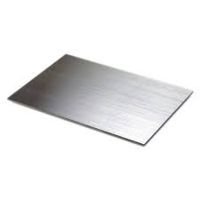 2.2 Model and Technical specification:

**Fig. 2.2** Specimen plate of Dimension 300 X 300 X 20 mm

**Table 2.1**

Shows Properties of specimen plate when different materials are considered.

|  |  |  |
| --- | --- | --- |
| Material | Aluminium | Steel |
| Dimension (mm) | 300 X 300 X 20 mm | 300 X 300 X 20 mm |
| Density (kg/m3) | 2710 | 7850 |
| Mass (kg) | 15.50 | 5.03 |
| Young’s Modulus  E (GPa) | 70 | 210 |
| Poisson’s ratio  υ | 0.28 | 0.33 |

2.3 Formulation:

Considered and representing a rectangular plate with length ‘a’, width ‘b’ and thickness ‘h’ as geometrical parameters and Young’s modulus E, Poisson’s ratio υ and mass density ρ as material parameters. A co-ordinate system has set middle reference of the rectangular plate with ‘x’ and ‘y’ as co-ordinate along x and y axis, respectively in xy- plane for the cases of simply supported- simply supported (SS-SS), for clamped-clamped boundary conditions as shown

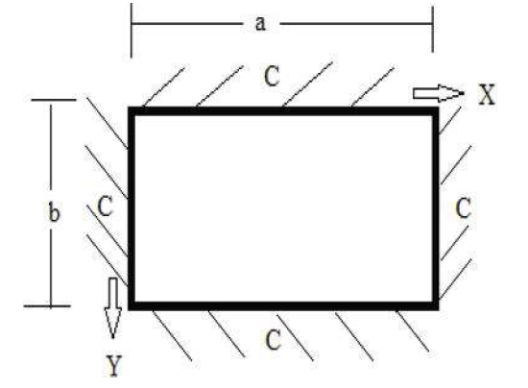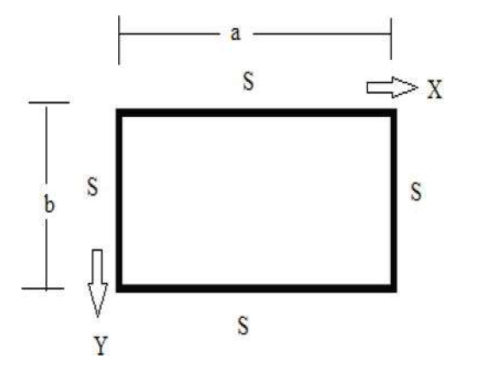

**Fig. 2.4** Plate 2 CC-CC

**Fig. 2.3** Plate1 SS-SS plate

The strain energy, $U$, of the plate when it is vibrating is expressed as:

$$U= \frac{1}{2} \int_{0}^{b}{\int_{0}^{a}{D{\left(\frac{∂^{2}w(x,y,t)}{∂x^{2}}+\frac{∂^{2}w(x,y,t)}{∂y^{2}}\right)}^{2}ⅆxⅆy}}$$

The expression for kinetic energy, $T$, of the plate is expressed as:

$$T= \frac{1}{2} ρh\int_{0}^{b}{\int_{0}^{a}{{\left(\frac{∂^{2}w(x,y,t)}{∂t^{2}}\right)}^{2}ⅆxⅆy}}$$

Here, ‘*t*’ denotes time variable, ‘*D* ‘designates flexural rigidity,

$$D= \frac{Eh^{3}}{12\left(1-ν^{2}\right)}$$

The Lagrangian function, in terms of kinetic and potential energy is written as :

$$L=T -U$$

The governing equation is obtained by applying Hamilton’s principle,

$$\int_{t_{1}}^{t_{2}}{δ\left(L\right)dt=0}$$

$$\int_{t_{1}}^{t_{2}}{δ\left(T-U\right)dt=0}$$

This process furnishes the governing equation that states the flexural vibration for the plate as:

$$\frac{∂^{4}w\left(x,y,t\right)}{∂x^{4}}+2\frac{∂^{4}w\left(x,y,t\right)}{∂x^{2}∂y^{2}}+\frac{∂^{4}w\left(x,y,t\right)}{∂y^{4}}+\frac{ρh}{D} \frac{∂^{2}w\left(x,y,t\right)}{∂t^{2}}=0$$

To determine the vibrational characteristic of the plate the variational method is used and the beam function is used, these functions are obtained from the solutions of the beam differential equations for various end conditions. The differential equation for a vibrating beam is written as:

$$\frac{∂^{4}w}{∂x^{4}}+α^{4}\frac{∂^{2}w}{∂t^{2}}=0$$

Solution of the above equation for the wave deformation displacement ‘*w*’ of the beam vibration can be truncated and written as:

$$w=e^{-ik_{m}x}e^{iωt}$$

Where,

$$k_{m}=\frac{πm}{a} and k_{n}=\frac{πn}{b}$$

Are used to evaluate natural frequency of the plate for the vibration parameters, m and n.

For splitting variables following modal displacement function form is adopted:

$$w\left(x,y,t\right)=X\left(x\right)Y\left(y\right)\sin\left(ωt\right)$$

Where $X\left(x\right) \& Y\left(y\right)$ are unknown functions.

Now, equation of motion of plate can be further written as,

$$\frac{∂^{4}X}{∂x^{4}}+2\frac{∂^{2}X}{∂x^{2}}\frac{∂^{2}Y}{∂y^{2}}+\frac{∂^{4}Y}{∂y^{4}}=\frac{ρhω^{2}}{D}$$

$X\left(x\right) \& Y\left(y\right)$ functions are of the following form,

$$X\left(x\right)=e^{-ik_{m}x}$$

$$Y\left(y\right)=e^{-ik_{n}y}$$

Further we can write,

$$\frac{∂^{4}\left(e^{-ik_{m}x}\right)}{∂x^{4}}+2\frac{∂^{2}\left(e^{-ik_{m}x}\right)}{∂x^{2}}\frac{∂^{2}\left(e^{-ik_{n}y}\right)}{∂y^{2}}+\frac{∂^{4}\left(e^{-ik_{n}y}\right)}{∂y^{4}}=\frac{ρhω^{2}}{D}$$

Or,

$$\left[k_{m}^{4}+{2k}_{m}^{2}k_{n}^{2}+k_{n}^{4}\right]=\frac{ρhω^{2}}{D}$$

Or,

$${\left[k_{m}^{2}+k_{n}^{2}\right]}^{2}=\frac{ρhω^{2}}{D}$$

Or,

$$ω=\sqrt{\frac{D}{ρh}} \left[k_{m}^{2}+k_{n}^{2}\right]$$

Boundary conditions:

Fully simply supported end conditions

$$w\left(0,y,t\right)=0,\frac{∂^{2}w\left(0,y,t\right)}{∂x^{2}}=0, w\left(a,y,t\right)=0,\frac{∂^{2}w\left(a,y,t\right)}{∂x^{2}}=0$$

$$w\left(x,0,t\right)=0,\frac{∂^{2}w\left(x,0,t\right)}{∂y^{2}}=0, w\left(x,b,t\right)=0,\frac{∂^{2}w\left(x,b,t\right)}{∂y^{2}}=0$$

For Fixed-Fixed end conditions

$$w\left(0,y,t\right)=0,\frac{∂w\left(0,y,t\right)}{∂x}=0, w\left(a,y,t\right)=0,\frac{∂w\left(a,y,t\right)}{∂x}=0$$

$$w\left(x,0,t\right)=0,\frac{∂w\left(x,0,t\right)}{∂y}=0, w\left(x,b,t\right)=0,\frac{∂w\left(x,b,t\right)}{∂y}=0$$

frequency formulas can be formed for the corresponding boundary conditions,

For SS-SS,

$$ω=\frac{π^{2}}{a^{2}}\sqrt{\frac{D}{ρh}} \left[m^{2}+\frac{n^{2}a^{2}}{b^{2}}\right]$$

For CC-CC,

$$ω=\frac{π^{2}}{{4a}^{2}}\sqrt{\frac{D}{ρh}} \left[{\left(2m+1\right)}^{2}+{\left(2n+1\right)}^{2}\frac{a^{2}}{b^{2}}\right]$$

$$w\left(x,y,t\right)=e^{-ik_{m}x}e^{-ik_{n}y}\sin\left(ωt\right)$$

2.4 Analytical Approach:

To perform the above caluculaion we have use MATLAB 2016. Since the calcultion consist of different variables simultaneouly involve, it was necessary to make a common platform to find a solution in less time. Hence a Graphical User Interface was created. Calculation of frequency and mode shaped are done separately.

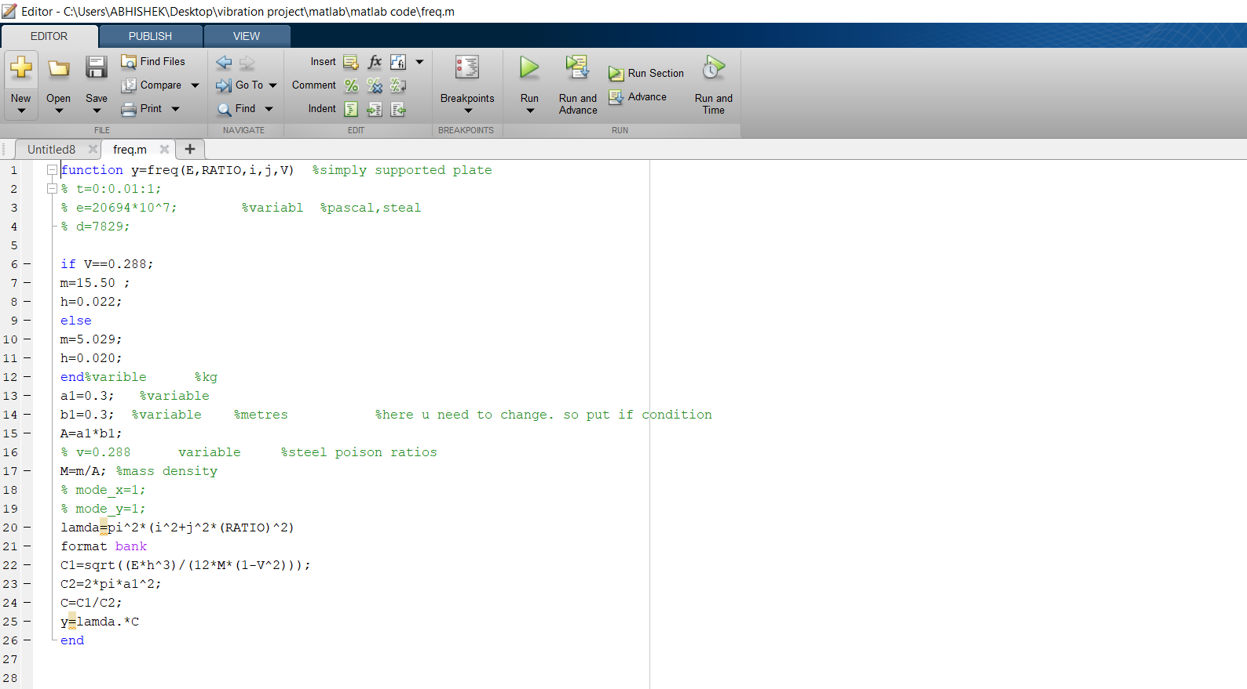

**Fig 2.5** Shows MATLAB code to calculate frequency.

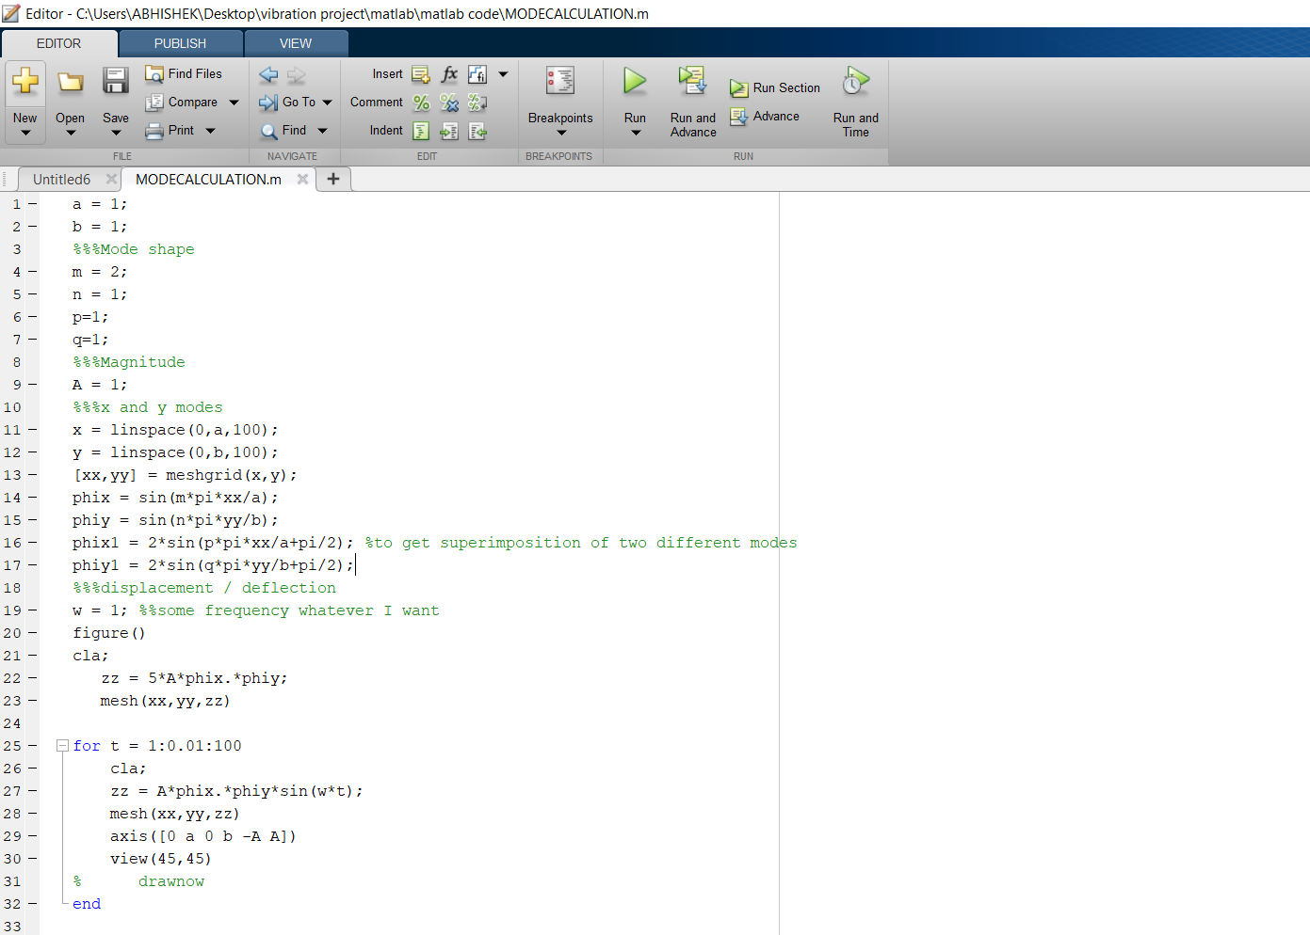

**Fig 2.6** Shows Matlab code to calculate mode shape.

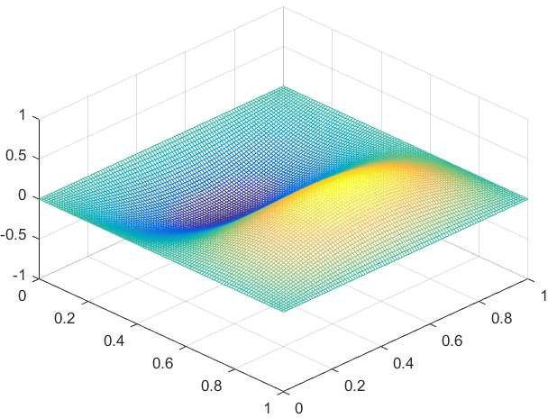

**Fig 2.7** Shows 2nd mode shape for aluminium

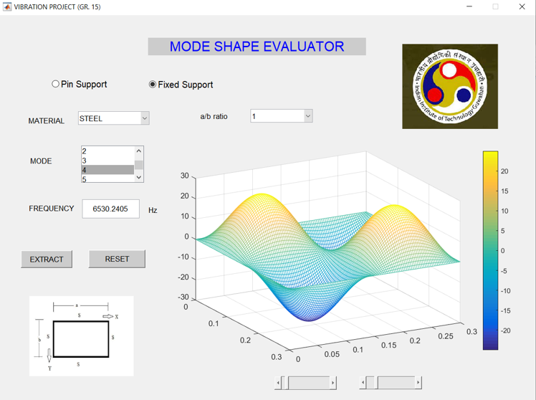

**Fig 2.8** Shows 4th mode shape of square steel plate for fixed support in GUI.

**Table 2.2**

Shows the Analytical values of frequency obtained in MATLAB for fixed- fixed boundary condition

|  |  |
| --- | --- |
| Mode No. | Frequency |
| 1 | 1991.34 |
| 2 | 4061.80 |
| 3 | 4061.80 |
| 4 | 5992.28 |
| 5 | 7281.48 |
| 6 | 7314.68 |

2.4 Numerical Approach:

The CAD model and CAE meshed model of the aluminium plate of dimension 300 X 300 X 20mm are shown below. For FEA, NX nastran with NASTRAN solver is used.

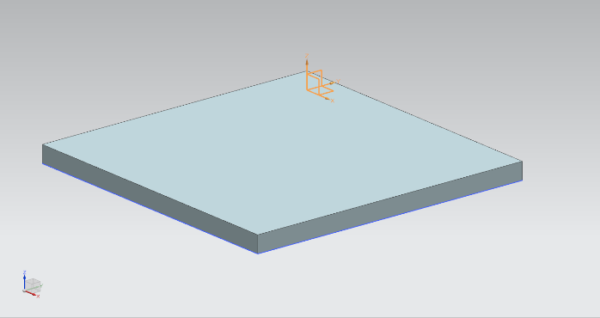

**Fig 2.9** CAD model of Al plate in NX Nastran.

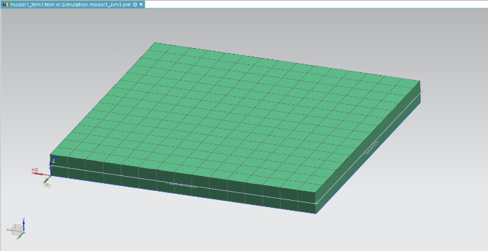

**Fig 2.10** CAE model of plate with 10 mm 2D Mapped meshing size in NX Nastran

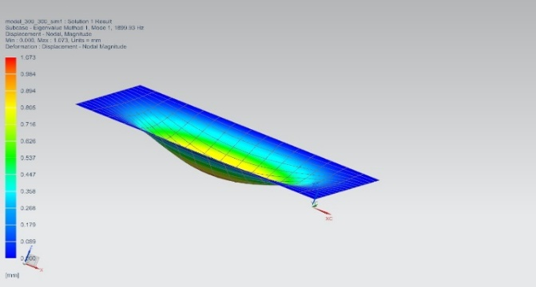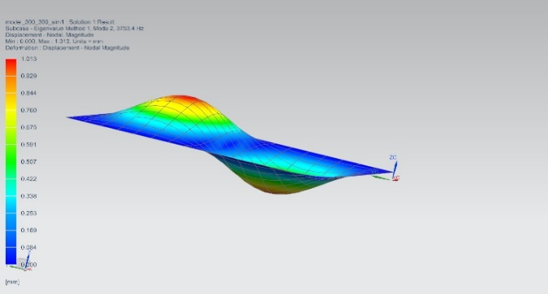

**Fig 2.11** Mode shape for mode 1, 2, 3, 4, 5 & 6 for Al plate of

Dimension 300 X 300 X 20 mm for fixed- fixed support

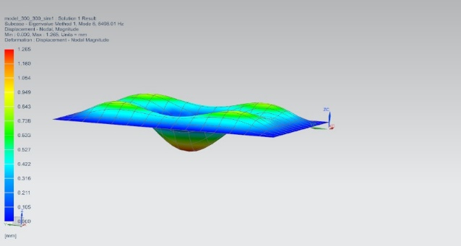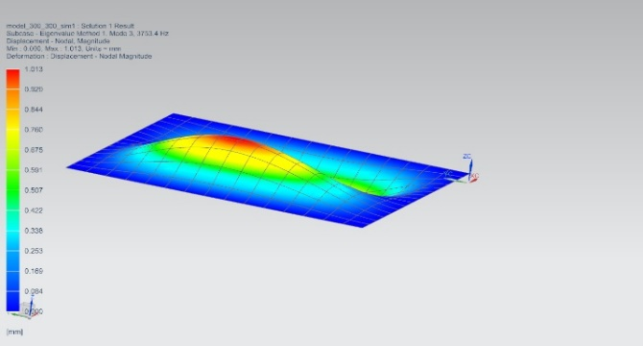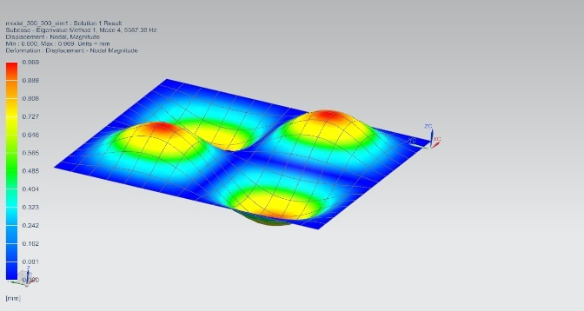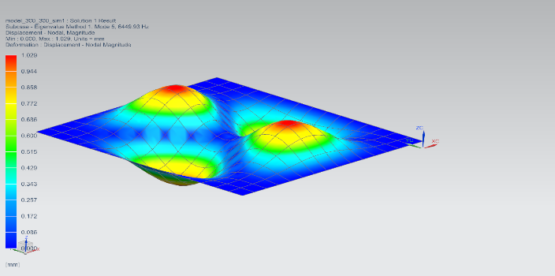

**Table 2.3**

Shows frequency at different modes for fixed- fixed boundary condition

|  |  |
| --- | --- |
| Mode | Frequency |
| 1 | 1899.93 |
| 2 | 3753.40 |
| 3 | 3753.40 |
| 4 | 5387.39 |
| 5 | 6449.93 |
| 6 | 6493.01 |

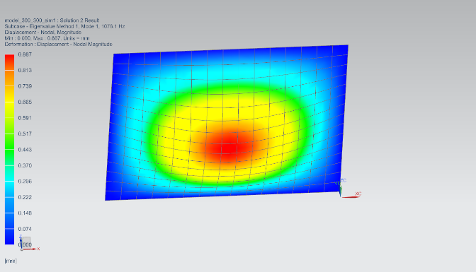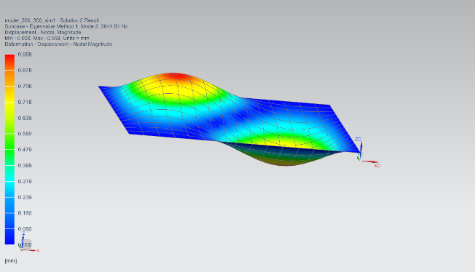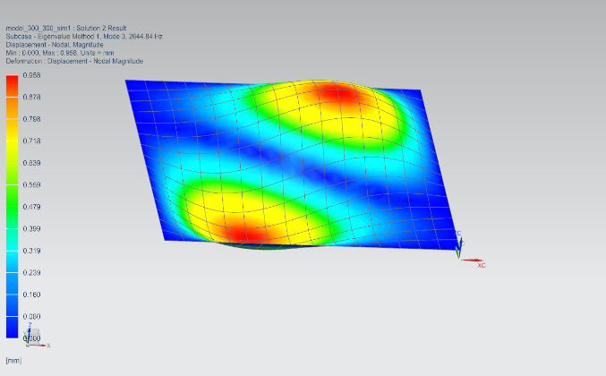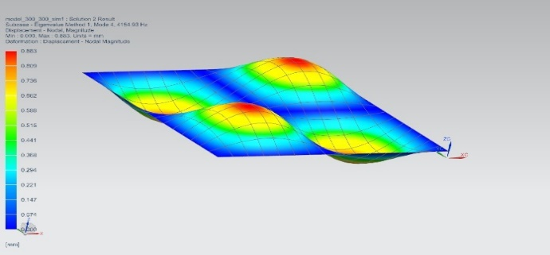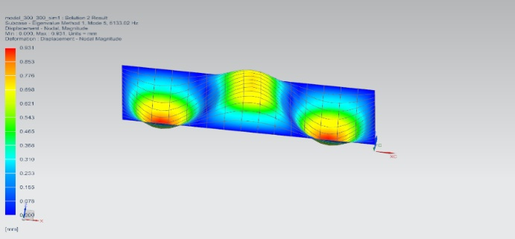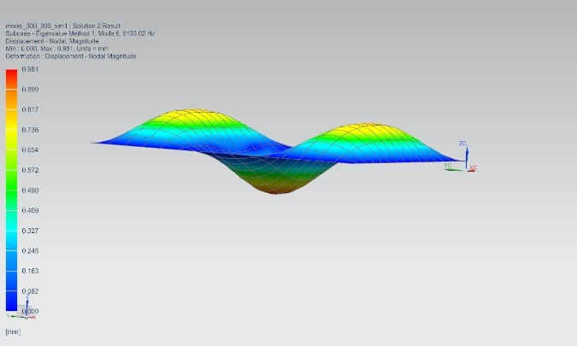

**Fig 2.12** Mode shape for mode 1, 2, 3, 4, 5 & 6 for Al plate of

Dimension 300 X 300 X 20 mm for free- free support

**Table 2.4**

Shows different mode frequencies of Al plate for free- free boundary condition

|  |  |
| --- | --- |
| Mode | Frequency |
| 1 | 1078.10 |
| 2 | 2644.84 |
| 3 | 2644.84 |
| 4 | 4154.43 |
| 5 | 5133.02 |
| 6 | 5133.02 |

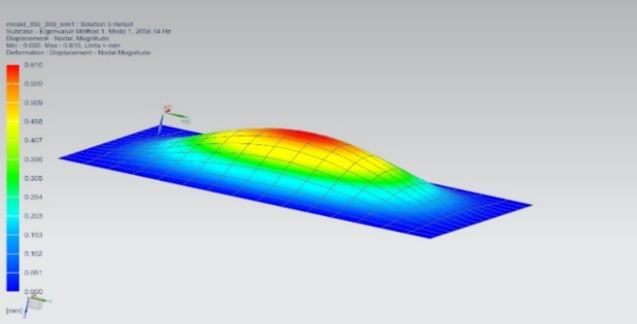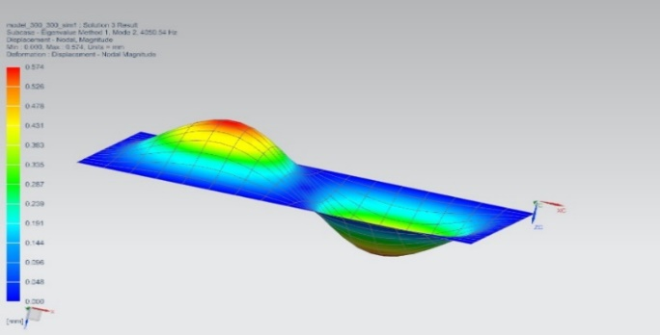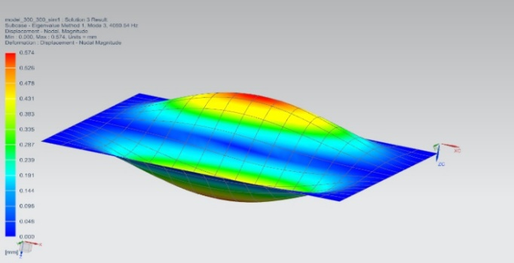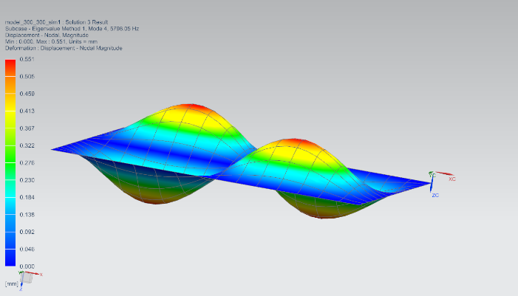

**Fig 2.13** Mode shape for mode 1, 2, 3, 4, 5 & 6 for steel plate of

Dimension 300 X 300 X 20 mm for fixed- fixed support

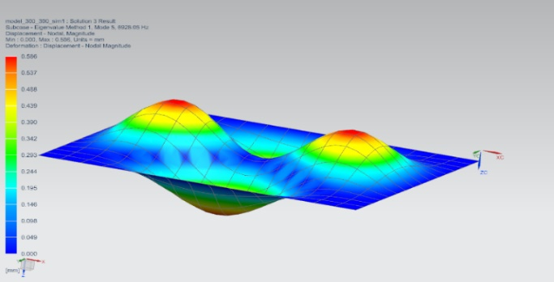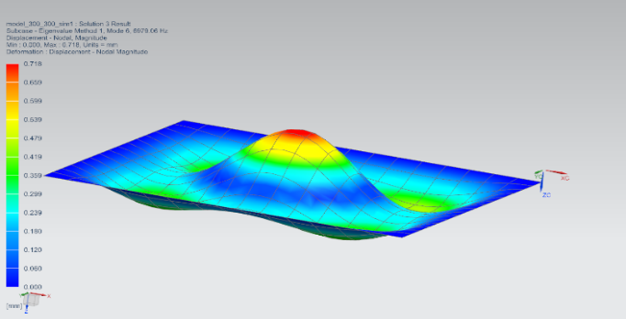

**Table 2.5**

Shows frequency for different mode value for steel plate of fixed- fixed boundary condition

|  |  |
| --- | --- |
| Mode no. | STEEL |
| 1 | 2058.14 |
| 2 | 4050.54 |
| 3 | 4050.54 |
| 4 | 5798.05 |
| 5 | 6928.05 |
| 6 | 6928.05 |

2.5 Experimental Approach

Modal testing is done to find the dynamic characteristic of system. Experimentally it is performed using harmonic exciter or hammer. For our plate hammer will be used. The setup requires DAQ system, excitor (hammer) and accelerometers. Using software likes FFT analyzer or MESCOPE VES the modal testing is performed.

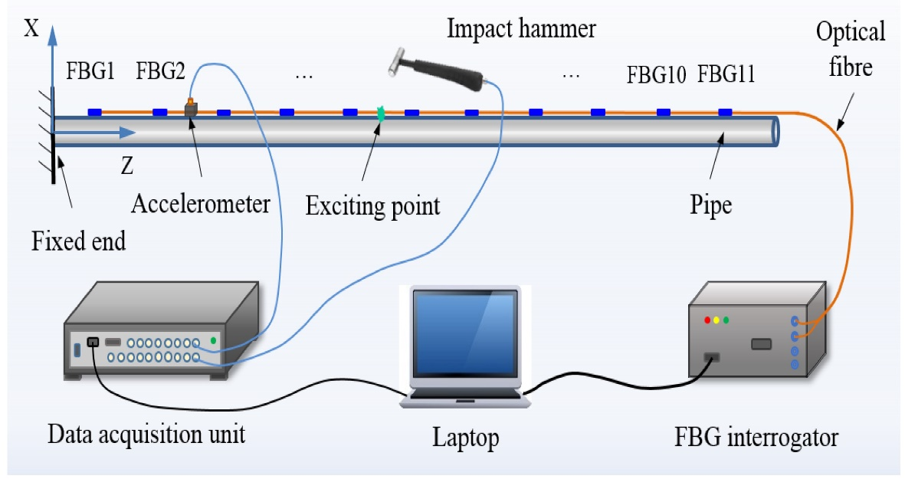

Fig 2.14 shows the sequential process of hammer impact test.

**CHAPTER 3**

**RESULT AND DISCUSSION**

The various modes shape and frequency has been found using MATLAB and compared with the FEA data. For our case the plate has to be placed in aerospace system like a missile which will be subjected to random vibration of frequency bandwidth 20-2000 Hz throughout its flight duration. Hence 20- 2000 Hz is the critical excitation frequency for our thin square plate. Therefor any frequency or mode falling in his range will get excited due to resonance and can cause damage.

Based on the modal participation factor found from NX NASTRAN it is clearly evident that 1st mode of aluminum 2014 and steel has more value as compared to others in the direction of vibration. Hence this mode and frequency will be present with highest fraction compared to others during flight.

Below is the comparison and error for different conditions.

**Table 3.1**

Shows Modal participation factor of fixed square plate. T1, T2, T3 are Translation D.O.F in x, y and z directions.

|  |  |  |  |  |
| --- | --- | --- | --- | --- |
| Mode No. | Frequency | T1 | T2 | T3 |
| 1 | 1.899935E+03 | 2.467906E-17 | 3.686861E-17 | -1.587979E+00 |
| 2 | 3.753403E+03 | -4.311504E-16 | -4.711226E-16 | 3.711766E-15 |
| 3 | 3.753403E+03 | -3.476214 E-16 | -2.060328E-16 | 1.161365E-14 |
| 4 | 5.387386E+03 | -4.174361E-15 | -4.451479E-15 | 2.243431E-15 |
| 5 | 6.449931E+03 | -4.084213E-14 | -1.465432E-13 | 4.262202E-14 |
| 6 | 6.496007E+03 | -7.426307E-13 | 2.743302E-13 | 9.912629E-01 |

**Table 3.2**

Shows solution for Aluminium 2014 plate with fixed boundary condition by different methods.

|  |  |  |  |
| --- | --- | --- | --- |
| Table for solution by different methods for aluminium plate with fixed boundary condition. | | | |
| Mode No. | Analytical | Numerical | Error (%) |
| 1 | 1991.34 | 1899.93 | 4.8122 |
| 2 | 4061.80 | 3753.4 | 8.2166 |
| 3 | 4061.80 | 3753.4 | 8.2166 |
| 4 | 5992.28 | 5387.39 | 11.2279 |
| 5 | 7281.48 | 6449.93 | 12.8924 |
| 6 | 7314.68 | 6493.01 | 12.6547 |

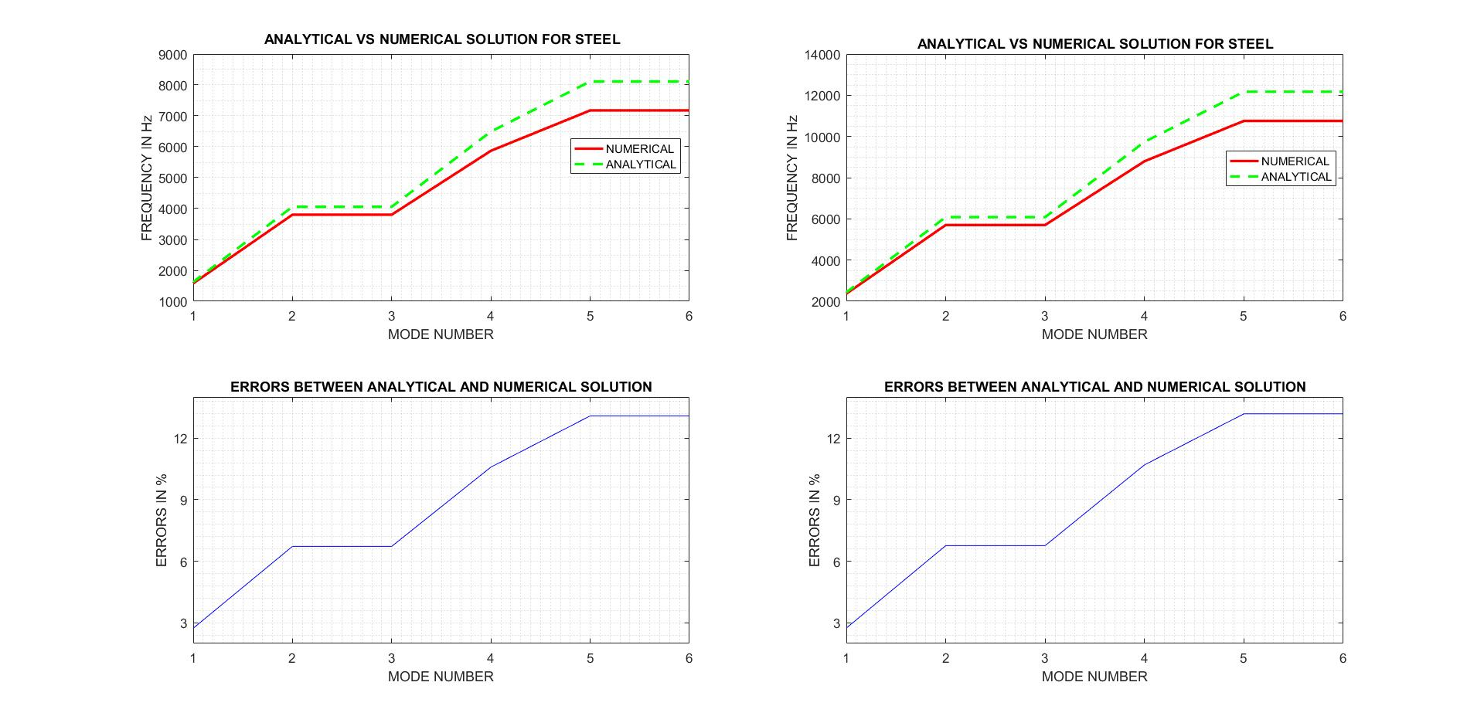

**Fig 3.1** graph ofMode number versus frequency for different solutions.

**Table 3.3**

Shows comparison between frequencies of free-free and fixed-fixed support for aluminium plate.

|  |  |  |
| --- | --- | --- |
| Table of frequency of aluminium plate for different Boundary condition | | |
| Mode | Free-Free support | Fixed – Fixed support |
| 1 | 1078.10 | 1899.93 |
| 2 | 2644.84 | 3753.40 |
| 3 | 2644.84 | 3753.40 |
| 4 | 4154.43 | 5387.39 |
| 5 | 5133.02 | 6449.93 |
| 6 | 5133.02 | 6493.01 |

**Table 3.4**

Shows comparison of frequencies between steel and aluminium for fixed boundary condition.

|  |  |  |
| --- | --- | --- |
| Table of frequency for material in NX Nastran  For plate of 300*300*20 mm with fixed boundary condition | | |
| Mode no. | FREQUENCY in Hz | |
|  | STEEL | ALUMINIUM |
| 1 | 2058.14 | 1899.93 |
| 2 | 4050.54 | 3753.4 |
| 3 | 4050.54 | 3753.4 |
| 4 | 5798.05 | 5387.39 |
| 5 | 6928.05 | 6449.93 |
| 6 | 6928.05 | 6493.01 |

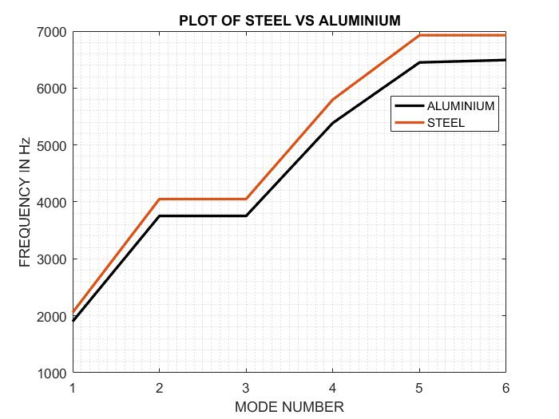

**Fig 3.2** Mode number versus frequency plot for steel and aluminium

From above it looks like steel is best choice for aerospace system. Its fundamental frequency is out of the critical bandwidth of 20-2000 Hz. But at the same time its mass is very high which ultimately will increase the cost of overall system. Also, steel is mostly rejected in aerospace components for being non aerodynamic friendly. Hence, we decided to go for aluminum 2014. Since its frequency lies in critical bandwidth, its structure needs to be modified.

**Structural modification:**

Structural modification includes addition of stiffener to the plate which increase its stiffness and hence increases its frequency.

Following is the dimension of various propose stiffener.

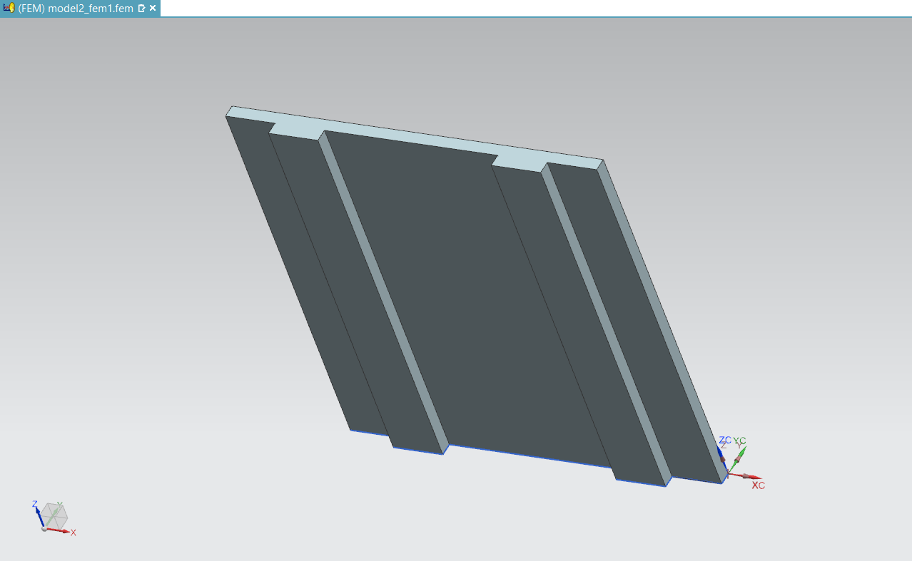

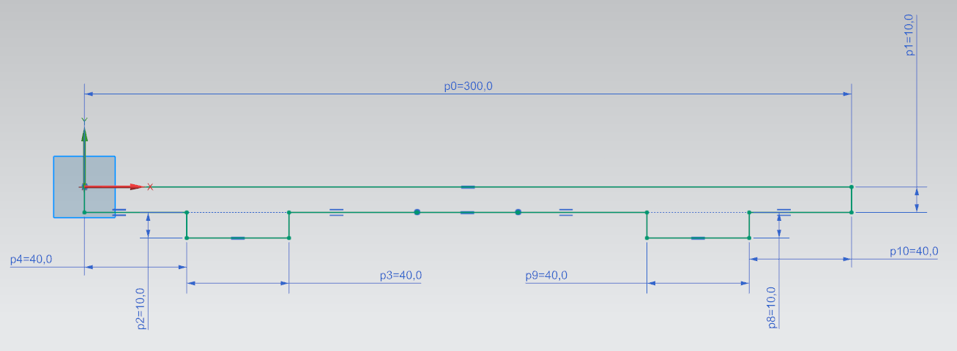

**Fig 3.3** Shows CAD model and dimension of aluminum 2014 plate with 2 stiffeners.

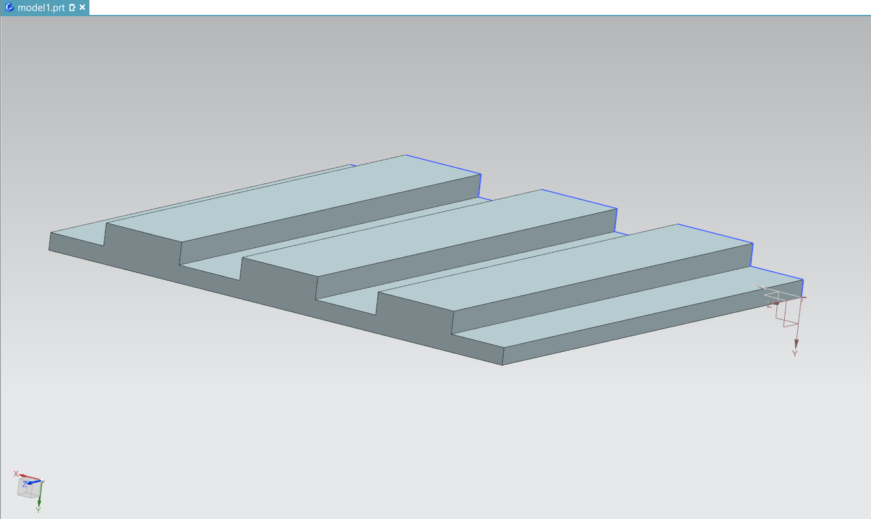

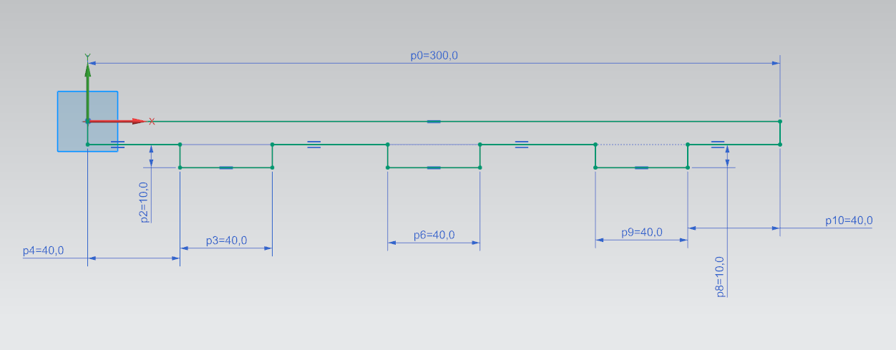

**Fig 3.4** shows CAD model and dimension of aluminum 2014 plate with 3 stiffeners.

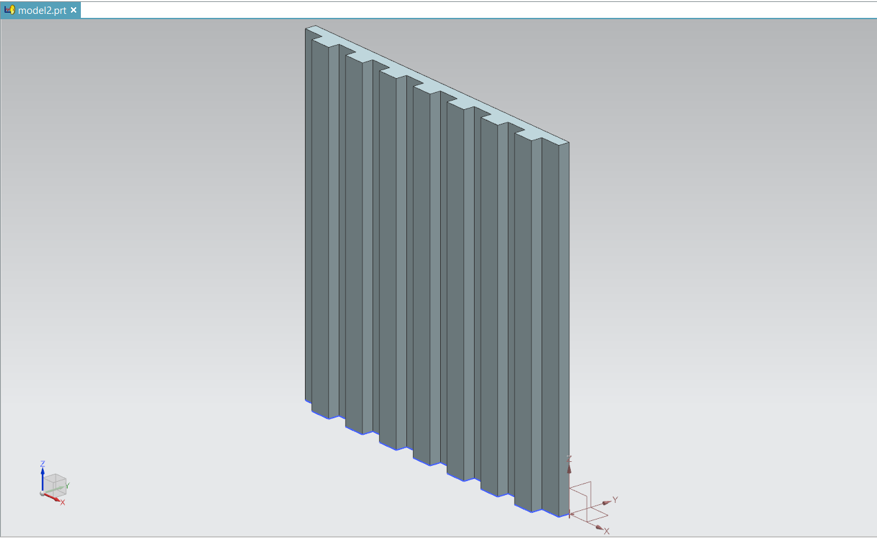

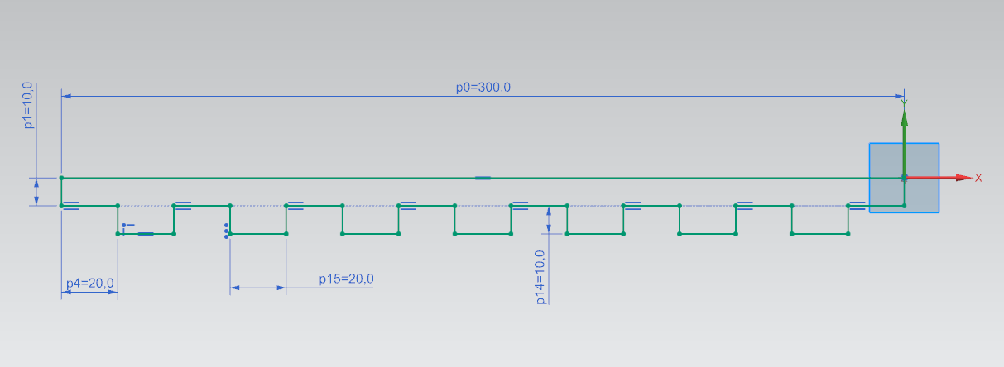

**Fig 3.5** Shows CAD model and dimension of aluminum 2014 plate with 3 stiffeners.

**FINITE ELEMENT ANALYSIS:**

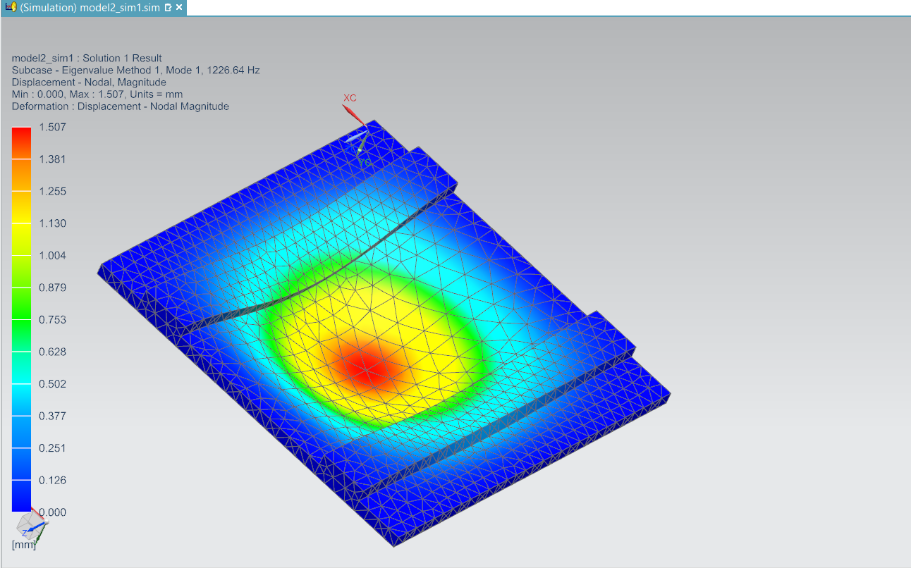

**Fig 3.6** 1st mode of 2 stiffener aluminum plate.

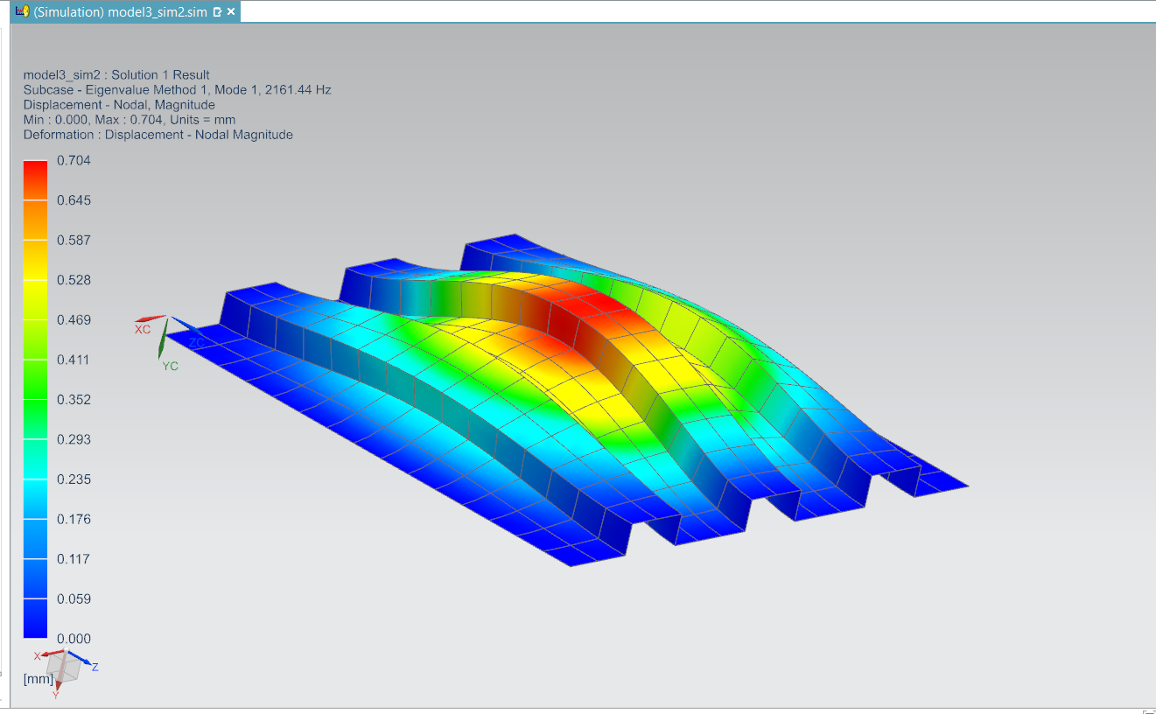

**Fig 3.7** 1st mode of 3 stiffener aluminum plate.

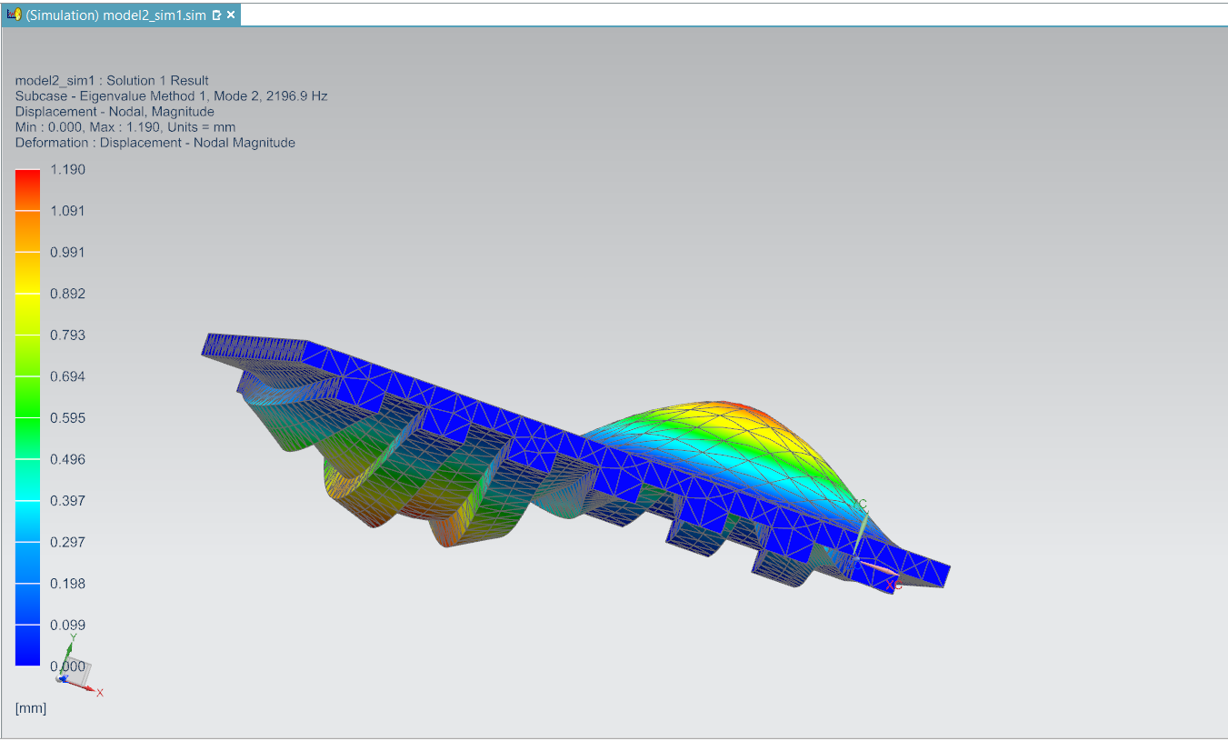

**Fig 3.8** 2nd mode of 7 stiffener aluminum plate.

**Table 3.5**

Shows frequencies comparison of aluminium plate with 2,3 and 7 stiffeners

|  |  |  |  |
| --- | --- | --- | --- |
| Table of Frequencies comparison of aluminium plate with 2,3 and 7 stiffeners | | | |
| Mode | 2 stiffeners | 3 stiffeners | 7 stiffeners |
| 1 | 1226.64 | 2164.44 | 1371.99 |
| 2 | 2164.48 | 2888.89 | 2196.99 |
| 3 | 2523.02 | 4588.13 | 3174.01 |
| 4 | 3646.74 | 4824.33 | 3566.34 |
| 5 | 3818.12 | 5238.39 | 3887.06 |
| 6 | 4247.28 | 5296.47 | 5122.7 |

**Table 3.6**

Shows comparison between frequencies of Aluminium 2014 plate before and after modification.

|  |  |  |
| --- | --- | --- |
| Table of frequency for aluminium Plate before and after Modification | | |
| Mode | Aluminium plate | Modified aluminium plate |
| 1 | 1899.93 | 2161.44 |
| 2 | 3753.4 | 2888.89 |
| 3 | 3753.4 | 4588.13 |
| 4 | 5387.39 | 4824.33 |
| 5 | 6449.93 | 5238.39 |
| 6 | 6493.01 | 5296.47 |

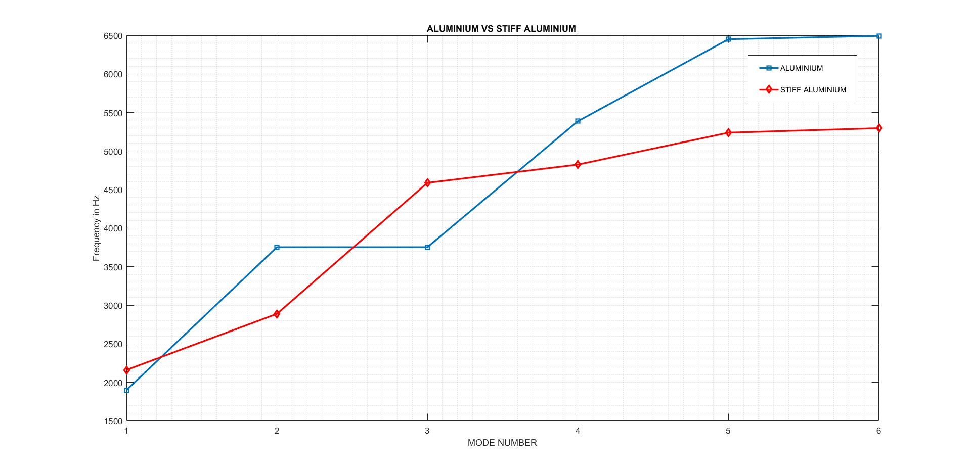

**Fig 3.9** Shows comparison between aluminum and stiff aluminum,

Based on the FEA RESULTS, 3 stiffeners are found to be best for aluminum 2014 @ 300*300*20 dimension. Also, the addition of three stiffener has increase the mass of system from 5.03 kg to 10.1 kg but is still less than 15.50 kg steel and is acceptable.

**Amount of Material and Cost Saved**

Cost is directly proportional to material.

$\left(\frac{15.50-10.1}{15.50}\right)*100=34.8 \%$

Hence about 35 % of cost is saved by using modified aluminum 2014 instead of steel.

**CHAPTER 4**

**CONCLUSION**

1. Analytical Solution Gives More Values of the frequency as Compared to Numerical Solution.
2. Deviation In Frequency and hence error increases at Higher Modes for Analytical Approach Making It Unsuitable to Use.
3. Steel is Stiffer Than Aluminium for the same Dimensions but has more mass making it unsuitable for aerospace system,
4. Simply addition of stiffener does not guarantee the change in frequency of the system.
5. Proper structural modification needs to be done based on critical mode shapes and environmental variables.
6. We covered most of Topics Present in our Curriculum such as

* Participation Factor and Its Physical Interpretations
* Reciprocity Theorem and Its Real-World Application.
* Lagrange And Hamilton Principles
* Modes Shapes and Its Interpretation.

**REFERENCES**

1. Composite Structures 89 (2009) 567–574, New exact solutions for free vibrations of thin orthotropic rectangular plates Y.F. Xing *, B. Liu.
2. Exact Solutions for Free-Vibration Analysis of Rectangular Plates Using Bessel Function BY H. L. Chen
3. Effects of various edge condition on free vibration and its characteristics od isotropic plates by M. Hussain.
4. Vibration of rectangular plate by Bhalcnandra Yashawant Belia (1966).
5. Fundamentals of Modal Testing by university of Massachusetts lowels USA.